Step by step Instructions for Entering JBC Gateway Tourneys on tournamentbowl.com

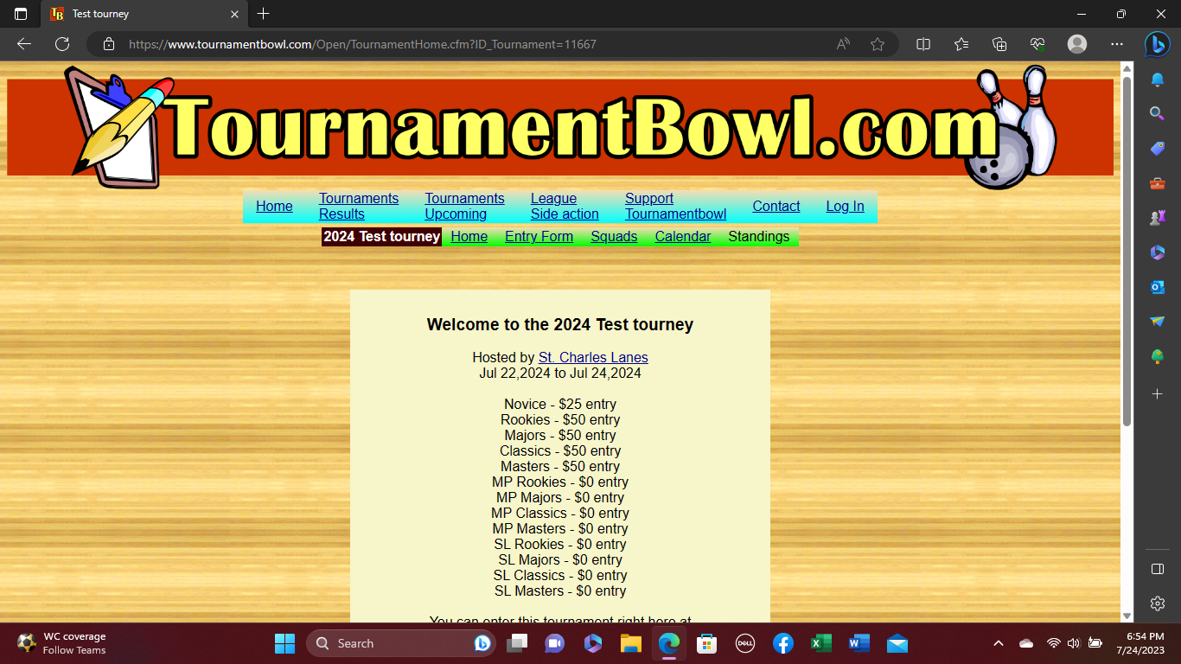

After selecting the specific tournament, you will see the above screen, please select the “Entry form” link to arrive at the following screen.
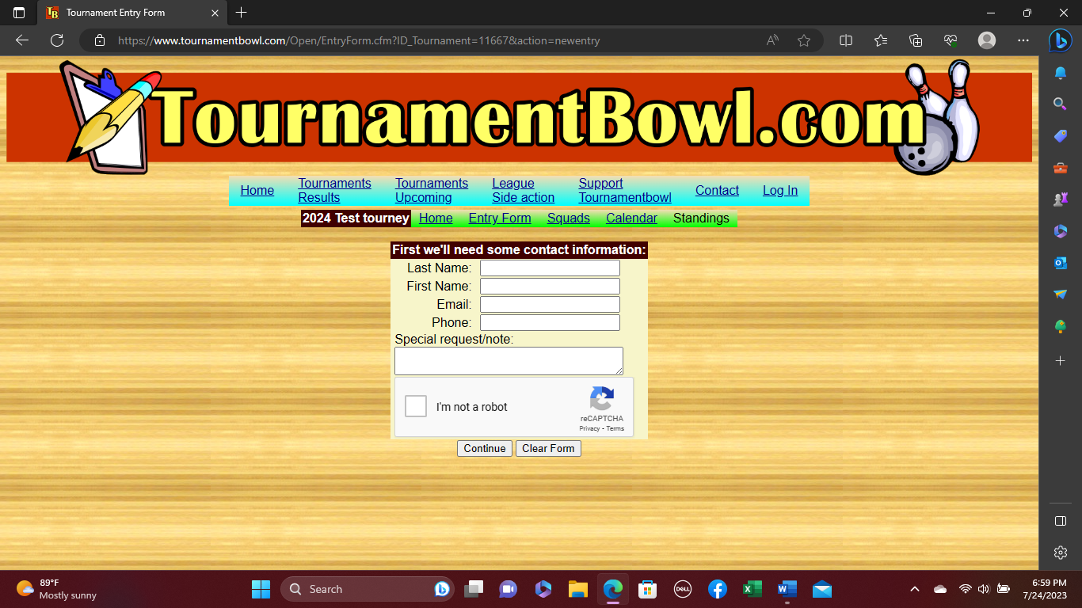
On the above screen, please enter contact information for person filling out the registration (parent or bowler) to include any applicable email address and phone number. Within the special request box, please indicate any other important info (request to be promoted, etc.). Also check the box “I’m not a robot” and then hit the continue button. You will then see the below screen.
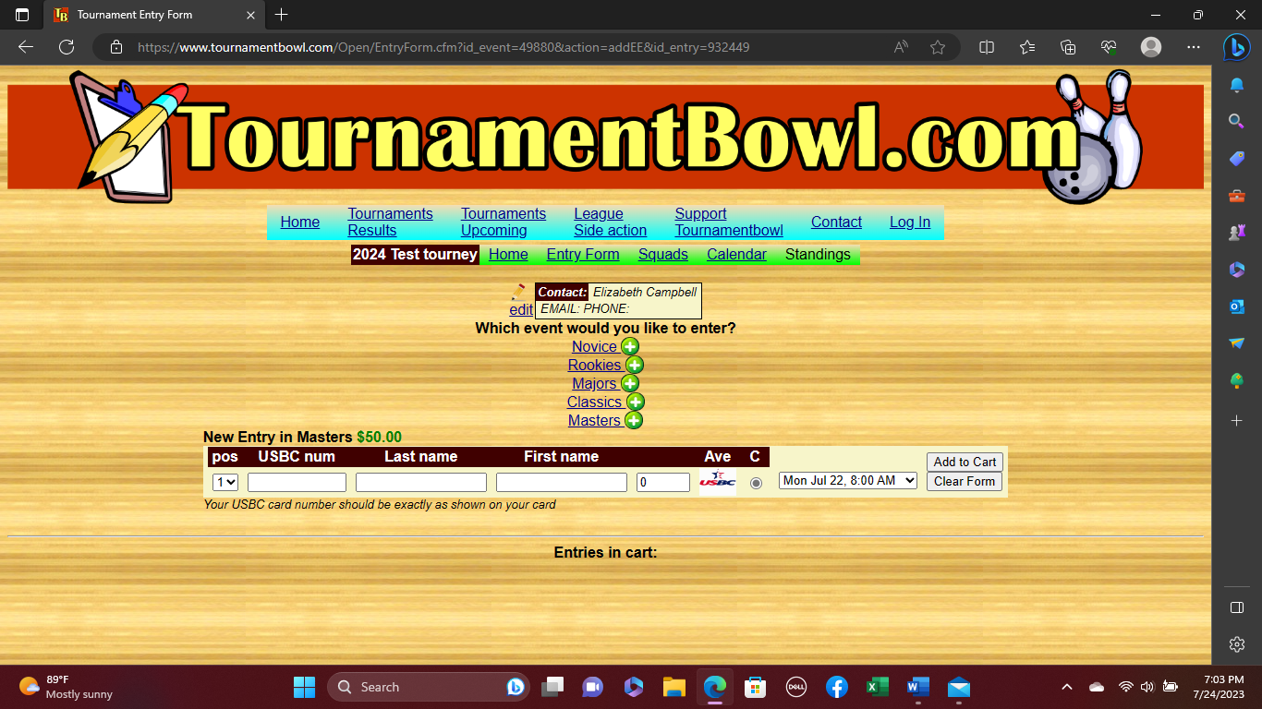

On the above screen please indicate which division you are currently bowling in; Novice (below 160), Rookies (160-175), Majors (176-189), Classics (190-205), or Masters (above 205). Also, enter USBC number, last name, first name and toggle to the specific squad you prefer by toggling the drop down field to the right (A squad 8AM or B squad 12:30PM), then hit “Add to Cart”. You will then see the following screen.
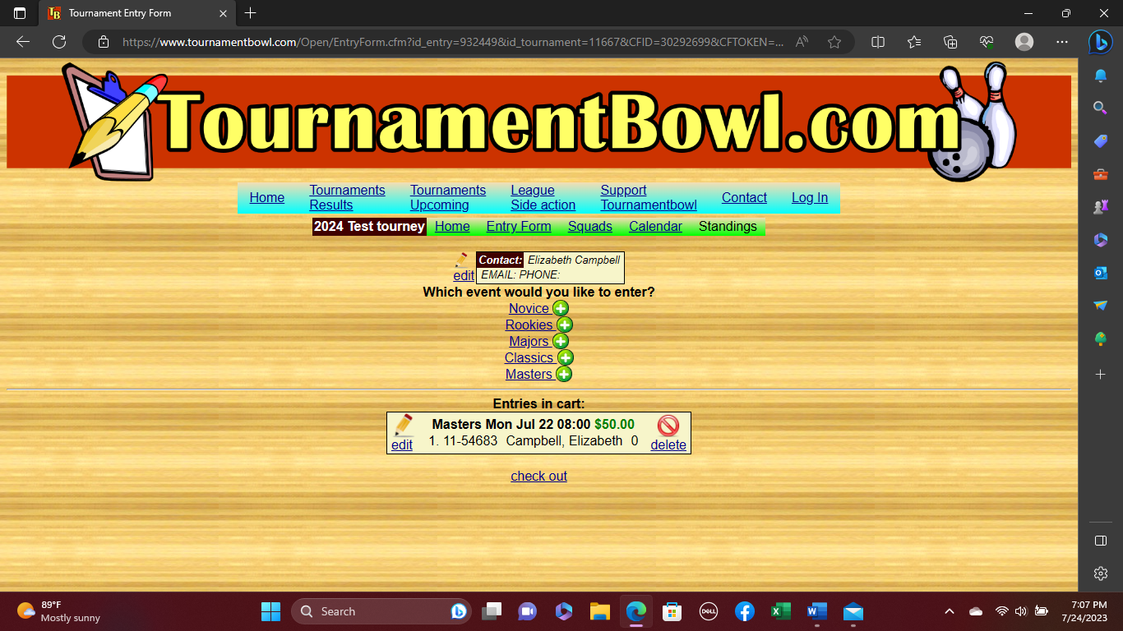
At this screen you will simply need to make any edits by clicking the edit button (with the pencil), delete (with the red crossed out circle) or the Check out button to submit as entered. You will see the following screen.
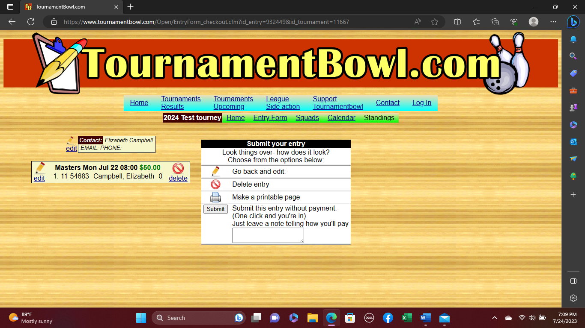
On this page, you’ll have the option to go back and edit, delete the entry, make a printable page, or submit the entry as is by clicking the submit button (there is no need to indicate how you’ll be paying).
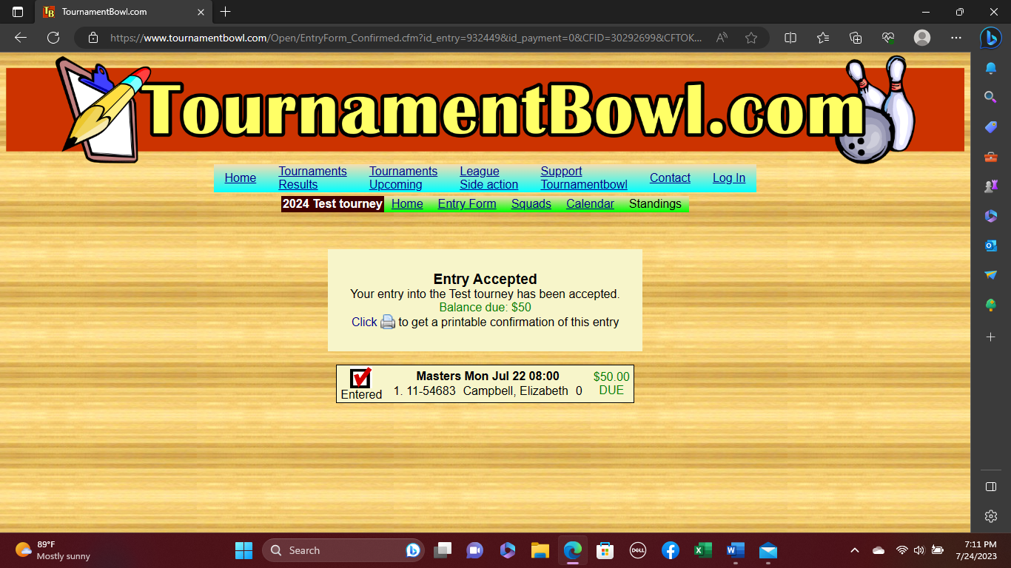

This final page will be your confirmation that your entry has been accepted. If you need to drop out of the tourney at any point, please contact one of our tourney directors via email or telephone.

